FRONTEND ASSIGNMENT-1
Ques1. HTTP Request–Response Cycle.

Ans1.
The HTTP Request–Response Cycle is the process through which a client, usually a web browser, communicates with a web server to obtain a web resource such as an HTML page, image, CSS file, or JavaScript file.

Major Steps-:
- User enters a URL: The user enters a website address in the browser.
- DNS lookup: The browser finds the IP address associated with the domain name.
- Connection is established: The browser establishes a connection with the web server, commonly using TCP and, for HTTPS, TLS.
- HTTP request: The browser sends an HTTP request to the server. The request contains information such as the HTTP method, URL/path, headers, and sometimes a body.
- Server processes the request: The web server receives the request, processes it, and accesses required resources or databases if necessary.
- HTTP response: The server sends an HTTP response containing a status code, headers, and usually a response body.
- Browser processes the response: The browser interprets the received HTML and requests additional resources such as CSS, JavaScript, and images.
- Web page is displayed: The browser renders the resources and displays the web page to the user.

Diagram-:
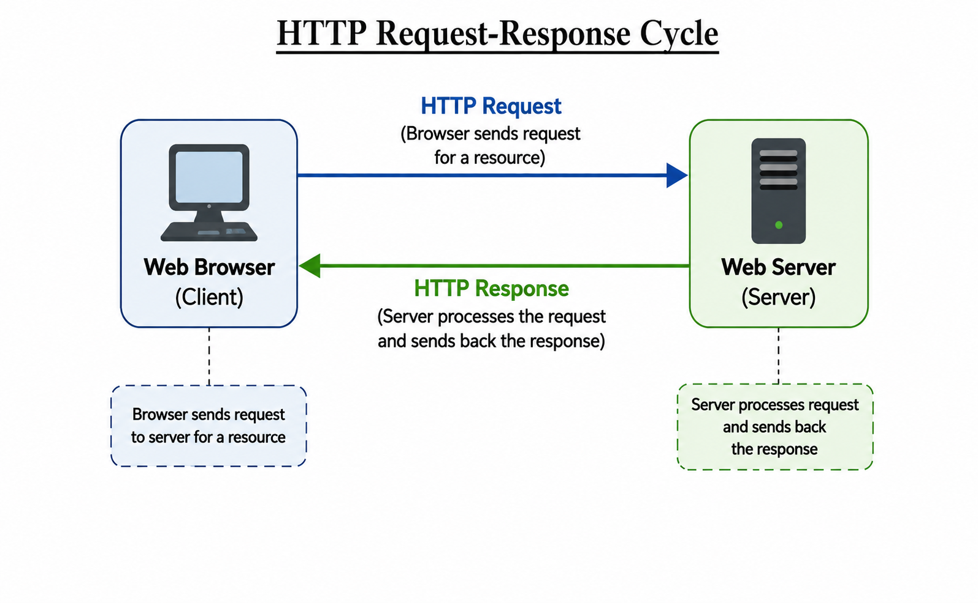
Ques2. Introduction to Web Technologies.

Ans2.
1. HTML
HTML (HyperText Markup Language) is used to create the structure and content of a web page.
Key features:
- Defines headings, paragraphs, images, links, tables, and forms.
- Uses tags and elements to structure content.
- Provides semantic elements such as <header>, <nav>, <main>, and <footer>.
- Forms the basic structure of most web pages.
Example:
<h1>Welcome to My Website</h1>
<p>This is a web page.</p>
2. CSS
CSS (Cascading Style Sheets) is used to control the appearance and presentation of HTML documents.
Key features:
- Changes colors, fonts, spacing, and backgrounds.
- Controls layouts and positioning.
- Supports responsive web design.
- Allows styles to be reused across multiple pages.
Example:
h1 {
color: blue;
text-align: center;
}
3. JavaScript
JavaScript is a programming language used to add behavior and interactivity to web pages.
Key features:
- Responds to user actions.
- Can modify HTML and CSS dynamically.
- Performs calculations and validation.
- Can communicate with servers without reloading the entire page.
Example:
alert("Welcome to my website!");
4. Bootstrap
Bootstrap is a popular frontend CSS framework used to develop responsive and mobile-friendly websites quickly.
Key features:
- Provides a responsive grid system.
- Provides ready-made UI components.
- Includes buttons, cards, forms, navigation bars, etc.
- Reduces the amount of CSS developers need to write.
Example:
<button class="btn btn-primary">Click Me</button>
5. jQuery
jQuery is a JavaScript library designed to simplify common JavaScript tasks.
Key features:
- Simplifies DOM manipulation.
- Provides easy event handling.
- Makes animations easier.
- Simplifies AJAX operations.
- Provides concise JavaScript syntax.
Example:
$("#message").hide();
6. React.js
React.js is a JavaScript library used for building user interfaces, particularly interactive frontend applications.
Key features:
- Uses reusable components.
- Supports efficient UI updates.
- Uses a declarative programming approach.
- Helps developers build complex interfaces from smaller components.
Example:
function Welcome() {
return <h1>Hello World!</h1>;
}

Ques3. Client-Side vs. Server-Side Technologies.

Ans3.
Client-Side Technologies
Client-side technologies run primarily on the user's device/browser.
They are responsible for the presentation and interaction that the user experiences.
Examples:
- HTML
- CSS
- JavaScript
- React.js
Server-Side Technologies
Server-side technologies run on the web server. They process requests, implement application logic, communicate with databases, and generate or return data to the client.
Examples:
- Node.js
- PHP
- Python
- Java
- C#
Difference
Client-Side | Server-Side
Runs in the user's browser/device | Runs on the web server
Handles user interface and interaction | Handles application/business logic
Code can be executed directly by the browser | Code is executed on the server
Examples: HTML, CSS, JavaScript | Examples: Node.js, PHP, Python
Focuses mainly on presentation and interaction | Can handle databases, authentication, and server operations

Example: When a user submits a login form, JavaScript may validate the form in the browser, while the server-side program verifies the username and password against a database.

Ques4. Block-Level Elements in HTML.

Ans4.
Block-level elements are HTML elements that normally start on a new line and occupy the available width of their containing element.
Characteristics
- Normally begin on a new line.
- Usually take up the full available width.
- Can generally contain other elements, subject to HTML rules.
- Can be styled using CSS for dimensions, margins, padding, and layout.
Examples
- <div>
- <p>
- <h1> to <h6>
- <section>
- <article>
Example:
<h1>My Website</h1>
<p>This is a paragraph.</p>
<div>This is a division.</div>

Ques5. Semantic HTML Elements.

Ans5.
Semantic HTML elements are elements whose names clearly describe the meaning and purpose of their content.
Examples include:
- <header> — represents introductory content or a page/section header.
- <nav> — represents navigation links.
- <main> — represents the main content of a document.
- <section> — represents a thematic section.
- <article> — represents an independent piece of content.
- <aside> — represents related or supplementary content.
- <footer> — represents footer information.
Importance
Semantic HTML is important because:
- Improves readability: The structure of a page is easier for developers to understand.
- Improves accessibility: Assistive technologies can better understand the page structure.
- Helps search engines: Meaningful structure can help search engines understand the content.
- Makes maintenance easier: Developers can identify the purpose of different parts of a page more easily.

Example:
<header>
<h1>My Website</h1>
</header>

<nav>
<a href="#">Home</a>
<a href="#">About</a>
</nav>

<main>
<article>
<h2>News</h2>
<p>Latest news goes here.</p>
</article>
</main>

<footer>
<p>Copyright 2026</p>
</footer>

Ques6. Creating a Table Using HTML.

Ans6.
<!DOCTYPE html>
<html>
<head>
<title>Employee Table</title>
</head>
<body>

<table border="1">
<thead>
<tr>
<th>Sr. No.</th>
<th>Name</th>
<th>Designation</th>
<th>Department</th>
</tr>
</thead>

<tbody>
<tr>
<td>1</td>
<td>John</td>
<td>Manager</td>
<td>Sales</td>
</tr>

<tr>
<td>2</td>
<td>Smith</td>
<td>Sr. Manager</td>
<td>Marketing</td>
</tr>

<tr>
<td>3</td>
<td>Jane</td>
<td>Manager</td>
<td>HR</td>
</tr>
</tbody>
</table>

</body>
</html>

Ques7. Creating a Nested List Using HTML.

Ans7.
<!DOCTYPE html>
<html>
<head>
<title>River List</title>
</head>
<body>

<ul>
<li>River
<ul>
<li>Ganga</li>
<li>Yamuna</li>
<li>Brahmaputra</li>
<li>Narmada</li>
</ul>
</li>
</ul>

</body>
</html>

Output
  - River
  - Ganga
  - Yamuna
  - Brahmaputra
  - Narmada

Ques8. Types of CSS.

Ans8.
There are three main ways to apply CSS to an HTML document: Inline CSS, Internal CSS, and External CSS.
1. Inline CSS
Inline CSS is written directly inside the style attribute of an HTML element.
Example:
<p style="color: red; font-size: 20px;">
This is a paragraph.
</p>
Advantage: Useful for applying a style to one specific element.
Disadvantage: It can make HTML difficult to maintain when many elements require styling.

2. Internal CSS
Internal CSS is written inside a <style> element, usually in the <head> section of an HTML document.
Example:
<!DOCTYPE html>
<html>
<head>
<style>
p {
color: blue;
font-size: 18px;
}
</style>
</head>

<body>
<p>This is a paragraph.</p>
</body>
</html>
Advantage: Useful when styles are specific to a single HTML page.
Disadvantage: The styles are not automatically shared with other pages.

3. External CSS
External CSS is stored in a separate .css file and linked to the HTML document.
HTML:
<!DOCTYPE html>
<html>
<head>
<link rel="stylesheet" href="style.css">
</head>

<body>
<p>This is a paragraph.</p>
</body>
</html>
style.css:
p {
color: green;
font-size: 18px;
}
Advantage: The same stylesheet can be used by multiple HTML pages, making websites easier to maintain.
Disadvantage: The browser needs to load the external stylesheet.

Ques9. Practical Understanding.

Ans9.
HTML, CSS, and JavaScript have different but complementary roles in web development. The assignment specifically asks for their roles and contributions to a web page.
Technology | Main Role | What It Contributes
HTML | Structure | Creates headings, paragraphs, images, links, forms, tables, etc.
CSS | Presentation | Controls colors, fonts, spacing, layout, and responsiveness
JavaScript | Behavior/Interactivity | Adds dynamic behavior, event handling, validation, and interactive features

Example
Consider a button on a web page:
HTML creates the button:
<button id="myButton">Click Me</button>
CSS controls its appearance:
button {
background-color: blue;
color: white;
padding: 10px;
}
JavaScript gives it behavior:
document.getElementById("myButton").onclick = function() {
alert("Button clicked!");
};
Therefore:
HTML = Structure
CSS = Style/Presentation
JavaScript = Behavior/Interactivity

Ques10. Short Answer.

Ans10.
1. What is the role of Bootstrap in web development?
Bootstrap is a frontend framework that provides pre-designed CSS classes and UI components for developing websites quickly. It provides a responsive grid system and components such as buttons, forms, cards, navigation bars, and alerts.
Its main role is to make web development faster, easier, and responsive across different screen sizes.

2. What is jQuery and why was it widely used in web development?
jQuery is a JavaScript library that simplifies common JavaScript operations.
It was widely used because it provided simpler syntax for:
- DOM manipulation
- Event handling
- Animations
- AJAX requests
- Cross-browser compatibility
For example:
$("#message").hide();

3. What is React.js and what problem does it solve in frontend development?
React.js is a JavaScript library for building user interfaces using reusable components.
It helps solve the problem of efficiently managing and updating complex, interactive user interfaces. Instead of manually updating every part of a page, developers can build the interface from components and let React manage UI updates.

Example:
function Welcome() {
return <h1>Welcome to React!</h1>;
}

Name: Kashish Goswami
University Roll no.: 22515000063
Section: NC

